
PRESS RELEASE –
For immediate release
USTAD SHAHID PARVEZ KHAN –
UK CONCERTS ANNOUNCEMENT
Not only does he represent the seventh generation of the sitar’s first family - the Etawah Gharana - but he is regarded as one of the finest musicians in the world.

4 UK DATES INCLUDE LONDON, BIRMINGHAM & BRISTOL.
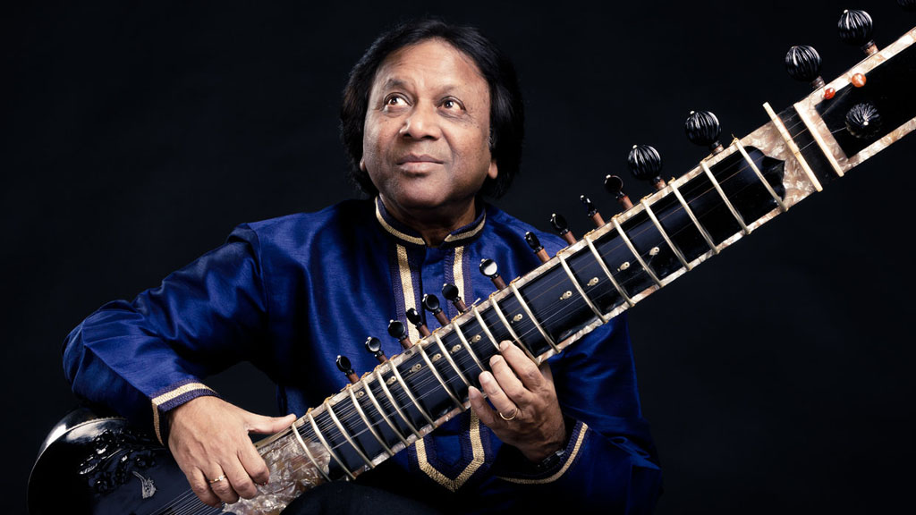

We are delighted to announce four UK concert dates with the sitar maestro of global acclaim Ustad Shahid Parvez Khan in July 2022, with accompaniment by outstanding tabla master, Sanju Sahai.

The concerts will take place at St George’s Bristol, Kings Place (London), Midlands Arts Centre (Birmingham) and Turner Sims (Southampton), presented by Asian Arts Agency.
Ustad Shahid Parvez Khan was initiated into the rich traditions of the Gharana by his father and guru, Ustad Aziz Khan and he is the nephew of legendary sitar maestro Ustad Vilayat Khan who is claimed by many to be on par with the great Ravi Shankar.
The recipient of numerous prestigious awards, including the Government of India’s Padma Shri and the Sangeet Natak Academy Award, Ustad Shahid Parvez Khan regularly tours across India, Europe, North America, Asia and Australia – enthralling audiences everywhere.
PUSHING BOUNDARIES
The power of Ustad Shahid Parvez Khan’s music emanates from the highly charged sound he conjures on stage. He emphasises the unique capabilities of the sitar itself while drawing upon numerous musical influences easily recognisable to a knowing ear. He has achieved success in not just preserving tradition, but also pushing out the boundaries to even greater heights of aesthetic beauty.

His playing style has inspired an entire generation of instrumentalists with his unique combination of emotional depth and brilliant technical mastery.

PRESS QUOTES

Indian music personified – The Hindu

It would not be an exaggeration if he is called unparalleled in his own arena in recent times – Telegraph India

ABOUT SANJU SAHAI

Sanju Sahai is one of the finest and most sought-after contemporary tabla players. Belonging to the Benares gharana, Sanju has performed internationally at prestigious venues including Carnegie Hall, Sydney Opera House and The Royal Albert Hall. He has accompanied many legendary musicians including Pandit Hari Prasad Chaurasia, Ustad Vilayat Khan Saheb.

UK CONCERT DATES
07 July 2022 Midland’s Arts Centre, Birmingham
09 July 2022 Turner Sims, Southampton
10 July 2022 Kings Place London
11 July 2022 St George’s Bristol

These dates are a golden opportunity to witness the sitar maestro perform live.

Jaswinder Singh, Director of Asian Arts Agency, said of Ustad Shahid Parvez Khan:
“We are pleased to finally proceed with this tour which was cancelled in 2020. It is an honour to be presenting an artist of such calibre as Ustad Shahid Parvez Khan. Belonging to the original sitar family, Ustad Shahid Parvez Khan is clearly one of the finest and influential musicians in the world. This tour promises to be an unforgettable musical experience serving a special opportunity for audience and artists alike to witness the sitar maestro perform live on stage.”

More information:
https://asianartsagency.co.uk/event/ustad-shahid-parvez-khan/
ENDS

Media information:

For more information, images and interview requests please contact:
Aashi Prime
Digital Co-ordinator
Asian Arts Agency
aashi@asianartsagency.co.uk

Notes to the editors:
Asian Arts Agency is a dynamic arts development agency based in Bristol that develops, promotes and supports international contemporary and traditional South Asian arts through performances, workshops, new commissions, tours, film screenings, new productions and ongoing support to artists.
Asian Arts Agency has worked with many world-class artists including Talvin Singh, Rizwan-Muazzam Qawwali, Roopa Panesar, DJ Rekha, Malkit Singh, Niladri Kumar, Gurdass Mann, The Dhol Foundation, Jazzy B, Susheela Raman, Anoushka Shankar, Transglobal Underground, and Zakir Hussain.

www.asianartsagency.co.uk

Facebook: www.facebook.com/AsianArtsAgency
Twitter: www.twitter.com/AsianArtsAgency
Instagram: https://www.instagram.com/asianartsagency/

